**Jenkins Installation Steps on AWS ec2 instance :**

**AWS ec2 Environment Details :**

Operating System : **CentOS-6.5-GA**

AMI-ID : ami-1a013c5f

Security Group Ports : 8888

**Set security group for instance – Go to security Group and add Custom TCP rule to 8888.**

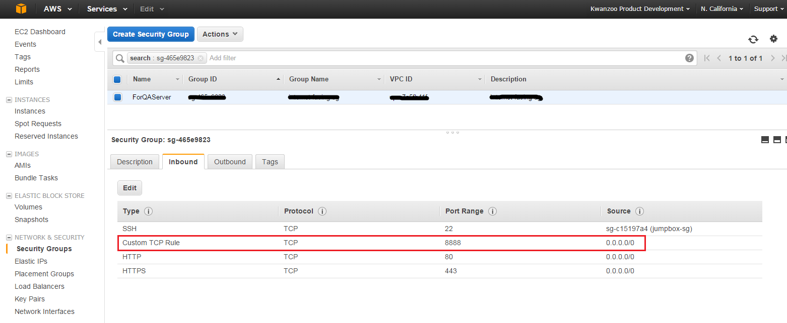

1. Please launch an Amazon Linux instance using Amazon Linux AMI.

2. Login to your Amazon Linux instance.

3. Become root using “sudo su -” command.

4. Update your repositories.

# yum update

5. Get Jenkins repository using below command.

# wget -O /etc/yum.repos.d/jenkins.repo<http://pkg.jenkins-ci.org/redhat-stable/jenkins.repo>

6. Get Jenkins repository key.

# rpm --import<http://pkg.jenkins-ci.org/redhat-stable/jenkins-ci.org.key>

7. Install jenkins package.

# yum install jenkins

By default Jenkins will start on Port 8080. You can change port depend on the requirement. I have changed it to 8888.

Go to **‘vi /etc/sysconfig/jenkins’** file and do the following changes:

JENKINS_PORT="8888"

JENKINS_AJP_PORT="-1"

8. Start jenkins and make sure it starts automatically at system startup. Some basic commands :

# service jenkins start

# chkconfig jenkins on

# service jenkins status

9. Open your browser and navigate to http://<Elastic-IP>:8888. You will see jenkins dashboard.

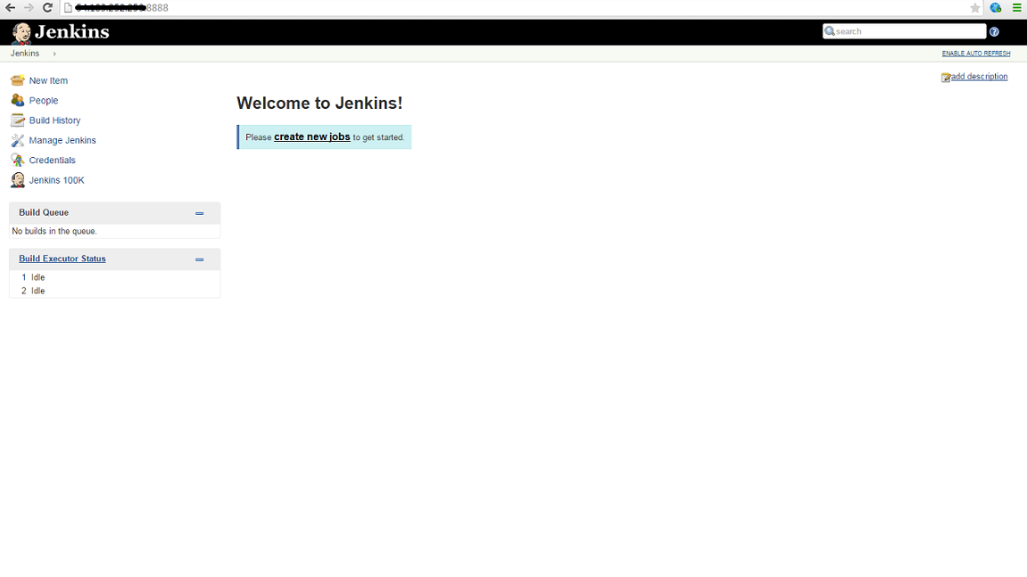

**Before creating any jobs in Jenkins do the following steps in ec2 instance if you want to change the Jenkins User :**

A. To change the jenkins user, open the **/etc/sysconfig/jenkins** (in debian this file is created in /etc/default) and change the **JENKINS_USER** to whatever you want. Make sure that user exists in the system (you can check the user in the **/etc/passwd file** ).

$JENKINS_USER="xxxx"

B. Then change the **ownership of the Jenkins home, Jenkins webroot and logs**.

$ chown -R xxxx:xxxx /var/lib/jenkins

$ chown -R xxxx:xxxx /var/cache/jenkins

$ chown -R xxxx:xxxx /var/log/jenkins

C. Then restarted the Jenkins and check the user has changed.

10. Now that everything is up and running, it's time to **create our first job**. Click the New Job link:

Fill up necessary details: Project name, Description, select **Build Step as Execute shell** and provide command as ‘uptime’ and Click on ‘Build Now’.

